Assignment-5

Q1.

Solution:

SEO, or Search Engine Optimization, is a set of practices aimed at optimizing websites to enhance their visibility and ranking in search engine results. The primary goal is to improve a website's organic (non-paid) traffic by optimizing various elements, including content, meta tags, and site structure. The ultimate objective is to provide users with the most relevant and valuable information based on their search queries.

The importance of SEO -

Meta tags are important for SEO because they provide information to search engines about the content on your

site and can help improve your website's visibility and ranking in search engine results pages.

Q2.

Solution

<!DOCTYPE html>

<html lang="en">

<head>

<meta charset="UTF-8" />

<meta name="viewport" content="width=device-width, initial-scale=1.0" />

<title>RAM PARAB</title>

<meta name="title" content="nothinggggggg” />

<meta name="description" content="Enhance your online presence with our SEO-optimized web page.

Learn about the importance of SEO and key strategies for improving your website's visibility."/>

</head>

<body></body>

</html>

Q3.

Solution:

benifits

1. Better Search Results: Meta tags help search engines understand what your page is about, so it can show up in relevant search results.

2. More Clicks: A well-written meta description can make people more likely to click on your page when they see it in search results.

3. Nice Looking Shares: Meta tags control how your page looks when shared on social media, making it more attractive and informative.

4. Accessible Design:They contribute to a website's overall design, ensuring it looks good and works well on different devices and browsers.

5. Correct Display: Meta tags help display special characters correctly and provide instructions to search engines on how to handle your page.

6. Control for Web Crawlers: Some meta tags give instructions to search engines on how to treat your page – like whether to index it or follow certain links.

Q4.

Solution

Code

<!DOCTYPE html>

<html lang="en">

<head>

<meta charset="UTF-8" />

<meta name="viewport" content="width=device-width, initial-scale=1.0" />

<title>Sample Blog Post - Semantic HTML</title>

</head>

<body>

<header>

<h1>RAM PARAB</h1>

<nav>

<ul>

<li><a href="/">Home</a></li>

<li><a href="/about">About</a></li>

<li><a href="/contact">Contact</a></li>

</ul>

</nav>

</header>

<article>

<header>

<h2>portfolio</h2>

</header>

<section>

<h3>Introduction</h3>

<p>

Passionate about growing in tech. Exploring web & software development.

Embracing challenges for continuous improvement.

</p>

</section>

</article>

<footer>

<p>&copy; 2002 . All rights reserved.</p>

</footer>

</body>

</html>

Output

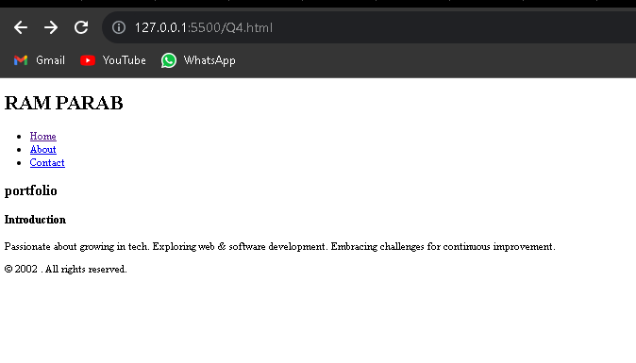

Q5.

A favicon, short for "favorite icon," is a small, usually square image or icon associated with a website. It appears in the browser's address bar, tabs, bookmarks, and sometimes in the browser history. Favicon images are typically 16x16 pixels or 32x32 pixels in size and are saved as ICO (icon) files.

Example:

<!DOCTYPE html>

<html lang="en">

<head>

<meta charset="UTF-8">

<meta name="viewport" content="width=device-width, initial-scale=1.0">

<title>My Website</title>

<!-- favicon -->

<link rel="icon" href="photo mee (1).jpeg" type="image/x-icon">

</head>

<body>

<!-- Page content goes here -->

</body>

</html>